**RR No.**

**Billing Period**

**Due Date**

08-08-2022 - 08-09-2022 22-09-2022

**Branch Cheque/DD No.**

**Disconnection Date**

07-10-2022

**Cheque/DD Date**

**Bill No.**

**Account ID**

(C5406)

**Name of the Bank**

790561155264

7905612222

**Amount (Rs.)**

**Amount Payable** Rs..10000

**Amount in Rupees**

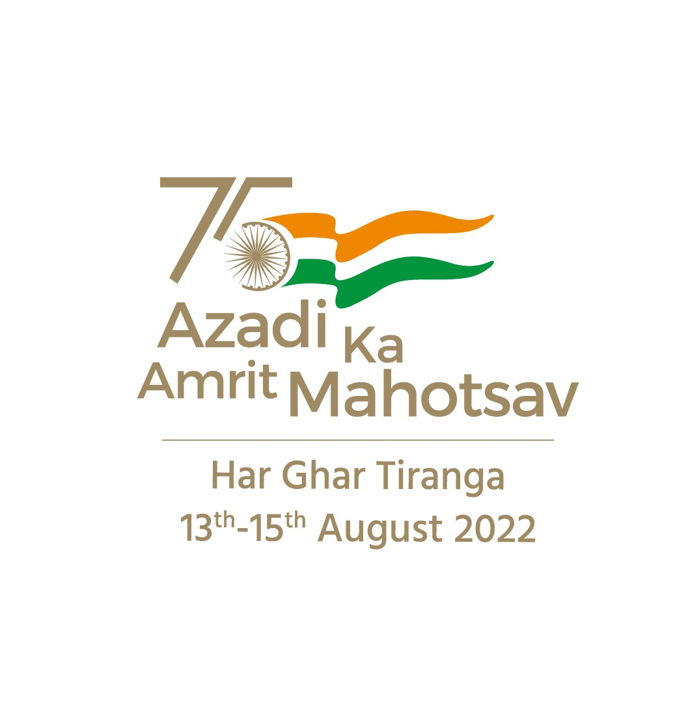

CESC GSTN No: **29AACCC6636P1Z1**

CESC PAN No: **AACCC6636P**

Office of the Asst. Executive Engineer (Ele.), C, O&M Sub-division - C.R. Patna Sub-Division

|  |  |  |  |  |  |  |  |  |  |
| --- | --- | --- | --- | --- | --- | --- | --- | --- | --- |
| **RR No.** | **Account ID** | | **Bill No.** | **Billing Period** | | **Bill Date** | | **Due Date** | **Disconnection Date** |
| (C5406) | 7905612222 | | **790561155264** | 08-08-2022 - 08-09-2022 | | 08-09-2022 | | 22-09-2022 | 07-10-2022 |
| **Name & Address:**  HEAD MASTER CR PATNA  , KAR -573116 | | Type | | | Domestic - LT2A | |  | | |
| Tariff | | | 3LT2A1-N | |
| Sanctioned load (KW) | | | 0.52 | |
| Sanctioned load (HP) | | |  | |

|  |  |  |  |  |  |
| --- | --- | --- | --- | --- | --- |
| **Meter Readings for Meter ID 7905612750** | | | | | |
| **Description** | **Date** | **KWH Meter** | **KVAH Meter** | **MD meter** | **PF** |
| Present Reading | 08-09-2022 | 29046 |  |  |  |
| Previous Reading | 08-08-2022 | 28862 |  |  |  |
| Difference |  | 184 | 0 |  |  |
| Meter Constant |  | 1 |  |  |  |
| Consumption |  | 184 | 0 | 0 |  |
| Less/Add: Consumption |  | 0 |  |  |  |
| Net Consumption |  | 184 |  |  |  |

|  |  |  |  |
| --- | --- | --- | --- |
|  |  | **Your Detailed Bill** | **Amount (Rs.)** |
| **Description** |
| Fixed charges: For the First 1.00 KW at Rs100.00 per kW | 100.00 |
| Energy Charges : For the first 50.000 KWH at Rs4.10 per KWH | 205.00 |
| Energy Charges : For the next 50.000 KWH at Rs5.60 per KWH | 280.00 |
| Energy Charges : For the next 84.000 KWH at Rs7.15 per KWH | 600.60 |
| Fuel Cost Adjustment Charges : 184.000 KWH at Rs0.19 per KWH | 34.96 |
| Interest on Revenue | 21.83 |
| Interest on Tax | 1.73 |
| Tax | 97.70 |
| **Current Bill Amount** | **1341.82** |
| **Arrears** | **7948** |
| **Bill Correction** | **0.00** |
| Bill rounding adjustment | 0.18 |
| **Net Payable Amount** | **10000** |
| **Ten Thousand repees Only** | |
|  | **Sd/-**  **Assistant Executive Engineer (Ele.)** | | |



Office of the Asst. Executive Engineer (Ele.), C, O&M Sub-division - C.R. Patna Sub-Division

s

**RR No.**

**Billing Period**

**Due Date**

08-08-2022 - 08-09-2022 22-09-2022

**Branch Cheque/DD No.**

**Disconnection Date**

07-10-2022

**Cheque/DD Date**

**Bill No.**

**Account ID**

(C5406)

**Name of the Bank**

790561155264

7905612222

**Amount (Rs.)**

**Amount Payable** Rs. 4394.00

**Amount in Rupees**

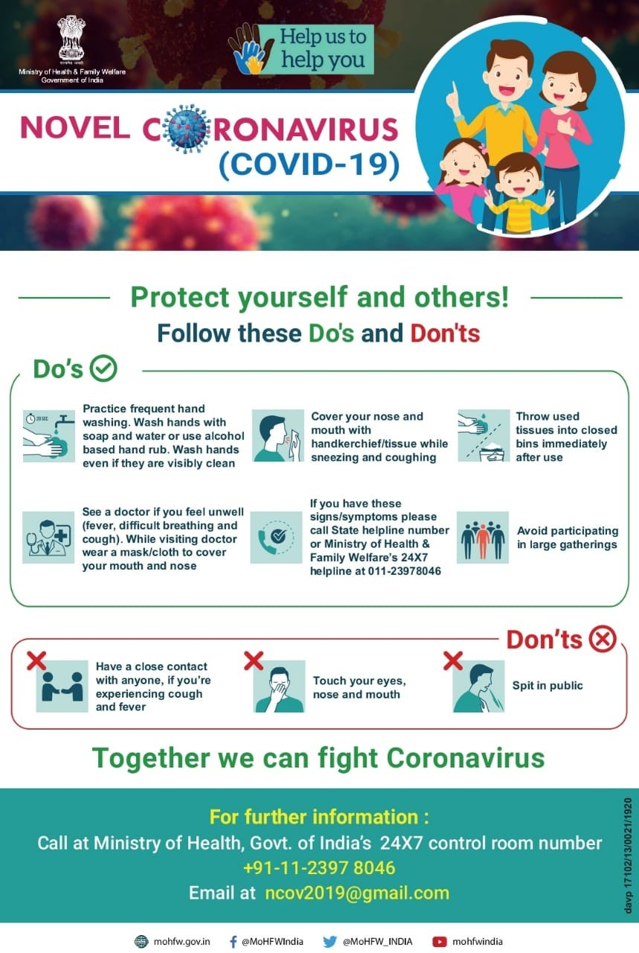



Office of the Asst. Executive Engineer (Ele.), C, O&M Sub-division - C.R. Patna Sub-Division